**EXP.NO:5** **DATE:27.03.2025**

**USER INTERFACE DESIGN**  
**Roll no: [230701199]**

**Muhammad Asif P A**

**AIM:**

Conduct task analysis for an app (**online shopping**) and document the user flow diagram using Lucidchart.

**Content:**

* **Task Analysis** - Write down task breakdowns
* **User Flows** - Create flowcharts for each task (Lucidchart)

**1) Task Analysis:**

**1. User Registration and Login Process**

1. **Start:** The user begins the registration/login process.
2. **Enter Login/Signup Info:** User inputs email, password, or registers.
3. **Correct Credentials?**
   * **Yes:** User is successfully logged in and directed to the homepage.
   * **No:** User is prompted to retry login or signup.

**Flow:**  
Start → Enter Login/Signup Info → Correct Credentials? (Yes) → Homepage

**2. Browsing and Searching Products**

1. User visits the homepage.
2. User navigates through categories or uses the search bar.
3. Products are displayed based on selection or search query.
4. User selects a product to view details.

**Flow:**  
Homepage → Browse Categories/Search → View Products → Select Product

**3. Adding to Cart and Checkout**

1. User selects a product and clicks "Add to Cart."
2. User can review cart items before proceeding.
3. User proceeds to checkout.
4. User enters shipping and payment details.
5. Order is confirmed, and payment is processed.

**Flow:**  
Select Product → Add to Cart → Review Cart → Proceed to Checkout → Enter Details → Order Confirmation

**4. Handling Failed Transactions**

1. If payment fails, the user is prompted to retry.
2. If payment fails again, the user is advised to use a different method.
3. If payment succeeds, order confirmation is displayed.

**Flow:**  
Payment Attempt → Payment Failed? → Retry Payment → Successful? (Yes) → Order Confirmed

**5. Order Tracking and Support**

1. User navigates to "My Orders."
2. User selects an order to view its tracking status.
3. User can contact support if needed.

**Flow:**  
My Orders → Select Order → View Tracking → Contact Support (if needed)

**2) Document User Flows Diagram (Using Lucidchart)**

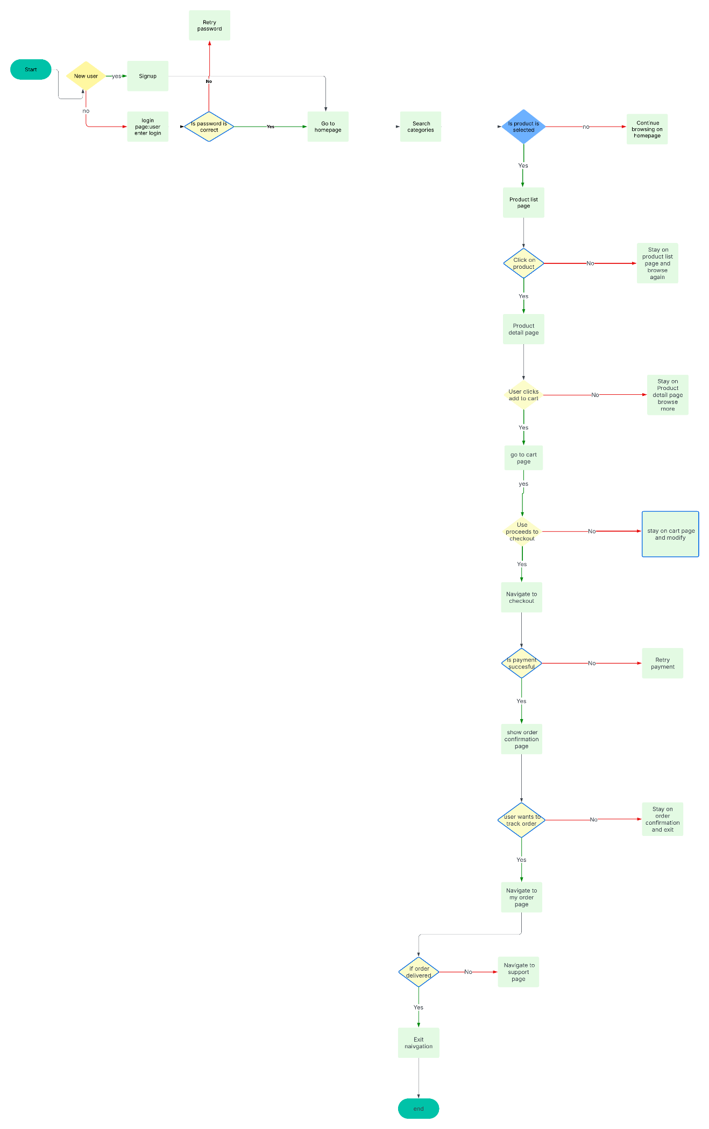

The above is my lucid chart for online shopping app

Here is the link of my lucid chart https://lucid.app/lucidchart/c6e22efa-d35d-40c6-8633-e8dfbbe9d815/edit?view_items=Ar64._G0nz6K&invitationId=inv_8826dcc0-6e91-4c27-9d4d-c12b3367dfd3